CIS660 AUTHORING TOOL PROGRESS REPORT
To be sent to SHL via email by midnight on Friday of each week
WEEK OF:__________2__________
Name of Authoring Tool _______Interlocker_________________
- Current date: _______03/12/2017___________
- Name: _______Jiongjian Chen___________
Task Activities since the Last Report
- Tell me what Design Doc work plan tasks you worked on over the past week
2. Construct Parts-graph
2.1. Generate initial parts-graph with given furniture model
2.2. Merge degree-1 nodes in the graph with their adjacent parts
2.3. Analyze and identify groups of overlapping cycles in the parts-graph
- Tell me specifically what the work consisted of and what was accomplished
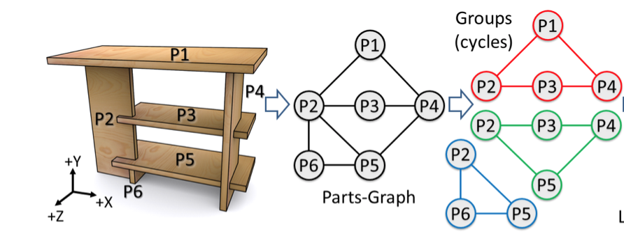
This picture better illustrates the progress for this week. Based on the furniture models we obtained and modeled from last week, we construct parts-graph(in the middle) from the model, then we analyze and identify groups of overlapping cycles in the parts-graph, and divide them into small groups(different than using DFS algorithm). These small groups are called LIGs, they will be the basis for later steps.
- List the number of hours you worked on each of these tasks this week
Mohamed and I worked on these tasks together.
2.1. Generate initial parts-graph with given furniture model - 5 hours(bookshelf, baby bed, shoe rack, bench, bed stand, console table, sofa, chair, child bed and multi-function table)
2.2. Merge degree-1 nodes in the graph with their adjacent parts – combined with 2.1
2.3. Analyze and identify groups of overlapping cycles in the parts-graph – 5 hours
- List the total number of hours you have spent working on your authoring tool since the start of the project
20 hours
Activities Planned for Next Week
- Tell me what you will be working on next week and what you plan to accomplish in terms of the work plan tasks and milestones
Next week’s tasks are as follows according to the work plan(a little adjustment):
4. ConstructLIG-graph–3weeks
4.1. Implement conditions for a cycle of parts to be local interlocking (considering 3- and 4-part cycles)
4.2. Implement rules for expanding an existing LIG
4.3. Implement three conditions for constructing LIGs with dependency in assembly / disassembly order.
4.3.1. Construct base case G1, which is the first one
4.3.2. Construct Gj that shares parts with only one previously-constructed
LIG, say Gi (j>i), but not others
4.3.3. Construct Gj that shares parts with multiple previously-constructed
LIGs.
4.4. Obtain Assembly/Disassembly order
Work Plan Tasks Completed to Date
- Tell me what tasks you have completed to date (as defined in your Design Doc Work Plan)
1. BuildFramework – 1week
1.1. Model interlocking furniture parts in 3d Max or Maya
1.2. Implement user GUI interface dialog (MEL)
1.3. Implement command plugin framework (C++)
1.3.1. Write code stubs
2. ConstructParts-graph – 2week
2.1. Generate initial parts-graph with given furniture model
2.2. Merge degree-1 nodes in the graph with their adjacent parts
2.3. Analyze and identify groups of overlapping cycles in the parts-graph
Problem Areas
- Identify any significant technical issues, problems or roadblocks you have encountered (if any) which you think have or will affect your development schedule.
- We tried to automate the process of analyzing and identifying overlapping cycles by using certain algorithms, but since the divide of cycles is kind of arbitrary algorithm wise, we have not yet found an applicable solution to automate the process. But it doesn’t affect our development schedule.
- If you have fallen behind schedule, let me know the reason why. NOTE: Not being able to devote a significant amount of time to the project because of assignments in another class is not a valid reason!
We’re actually ahead of schedule for one week.

